38.36: a) From Eq. (38.23), 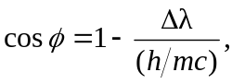and so a) 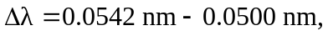
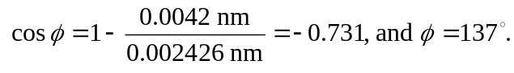
b)
c) 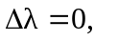the photon is undeflected, 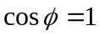 and 